The episodic prospection paradigm

how is it working?

In this paradigm subjects have to either imagine a new and speficif future event involving themselves or build a sentence comparing several objects.

A trial starts with a fixation cross (4-8s). Afterwards the participant are confronted with the task (in german we call task“Aufgabe”). They will see either the instruction to imagine a future event combined with a cue-word (episodic thinking condition) or to build a sentence combined with a cue word (sentence comparison condition). There are two lists of cue words which are counterbalanced across participants. Additionally during both task conditions the participant should be able to press a button to indicate when they have constructed the initial future event or the sentence. After the button press the participants should contemplate about the event or sentence until the rest of the task of the time ends (15s total).
Afterwards, participants should rate how detailled their thoughts were (same question for both task conditions).

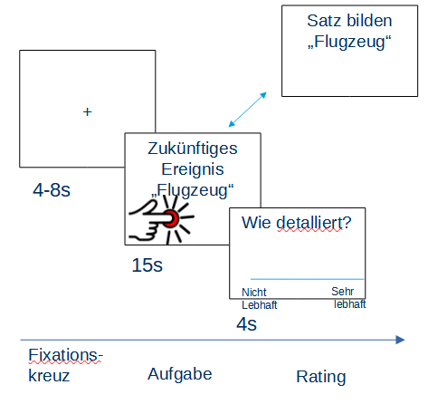

How does the task condition look like exactly?
Its quiet simple. In the episodic future condition people see the word “Imagine”, below “future event” and below the cue word (of course in the center of the screen).
In the sentence comparison condition people see the words “imagine” below sentence, size and below the cue word

What cue words are we using?
There are two lists of words for both task conditions which are counterbalanced across participants. For now I don’t list the words.

How many trials, what is their order and are there breaks?
There will be 40 trials in total. 20 for the sentence comparison task and 20 for the episodic future condition. The trials will be presented randomly.

Will there be breaks?
After 14 Trials (and 28 trials form the beginning) there should be a break of 30 seconds.
There should be a screen saying “Sie haben nun eine kurze Pause von 30 Sekunden” (You now have a short break of 30 seconds)
Self-control paradigm

This paradigm is kind of similar to the episodic prospection paradigm in the sense that the participants have to imagine something and rate their thoughts afterwards. Before going into the scanner they will see different social self-control scenarios. In these scenarios the protagonist does something impulsive although it might have some negative long-term consequences for him/her.

For example:
Coming home from work I see a coworker on the street. Although he might want to chat, I don’t feel like it and pretend I didn’t see him.
OR
During a party I see an attractive person constantly looking at me. Although I am interested in chatting with the person I stick to my friends.

Participants rate how much they think they would have the same urge to act like the protagonist. After the ratings the 24 scenarios with the strongest urge will be transferred to the actual paradigm.

In the actual paradigm the participants first see a cue indicating what kind of task they have to do and then the scenario/context. After reading the scenario they see a fixation dot during which they do the cued task. If the half-circle (cue) shows up, participants have to imagine acting like in the scenario (the impulsive behaviour) and to try feeling into the sensations that come with it (the pleasure of enacting it). If the half circle shows down, participants have to imagine the negative longterm consequences of that behaviour. After the task the participants rate how difficult the task was, how they felt during the task and how much urge they felt enacting the described behaviour. They have 5s for each rating.

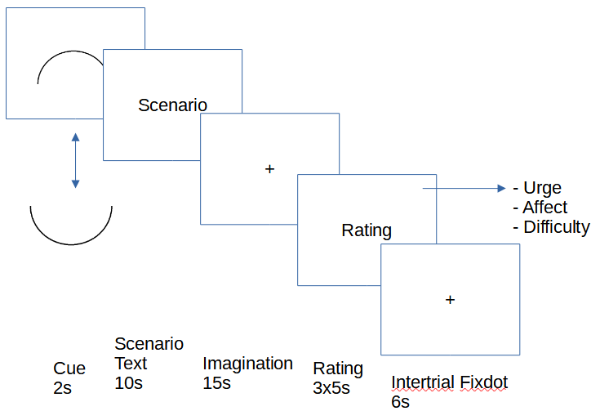

How many trials and in what order?
For now we planned 48 trials. Every scenario is shown twice with both of the cues. So participants imagine the behaviour and negative long term consequences for each scenario.
The trials will be randomized for every participant.

How will the ratings be given?
We use a continuos rating scale

Will there be a break in between?
I am currently not sure but I think one break in the middle of the experiment might be nessecary.

How are the scenarios chosen again?
The people will see like 40-50 scenarios and rate their urge to act the same way. Right now we are still evaluating the scenarios.

